**TERRA - EXHIBITIONS PROGRAM 2022 - CALL FOR PROPOSALS**

The cultural institution Center for Fine and Applied Arts Terra, Kikinda (hereinafter CLPU Terra) is announcing a competition for solo and group exhibitions for the exhibition year 2022. All academic artists in the field of visual and multimedia arts, as well as groups and associations of fine artists, have the right to participate in the competition. volunteers 25) and the Terra Museum (Stevana Sremca bb), the basics of which we submit in the attachments to the competition. After considering the concept of the exhibition, the Art Council decides on the location of its holding.

Competition documentation should contain:

* Completed application form for the competition (Appendix 4);
* Photographs of the works proposed for the exhibition (in JPEG or PDF format) with the indicated name, dimensions, technique, and year of creation. If the size of the total data exceeds 20MB send a share link (Wetransfer, g-drive, etc.)
* Artist's biography and concept/review of the exhibition in Word format (optional with English translation)

CLPU Terra provides:

* assembly and disassembly of the exhibition (pedestals, two LED TVs, video projector, laptop - if required in the application)
* organizes an opening and a cocktail party
* media support and printed publication - exhibition catalog
* transport of works by official vehicle (**Renault Kangoo Maxi, cargo space 190cm x 114cm x 110cm**) if it is located at a distance of **not more than 130km** (Belgrade or Vojvodina) or can bear the costs of sending works for installation by courier service, if feasible

Competition material can be submitted, with the title - "Application for the competition for the exhibition program 2022 (name and surname)", exclusively electronically to the e-mail address: [office@terra.rs](mailto:office@terra.rs) **no later than December 19, 2021, 23: 59h.**

The selection of exhibitions is decided by the CLPU Terra Art Council: Slobodan Kojić, MA, Master of Sculpture, founder and director of CLPU Terra, Verica Nemet, curator-art historian, CLPU Tera, Sava Stepanov, independent art critic, Novi Sad, Sanja Kojić Mladenov, Ph.D., museum advisor of MSUV, Novi Sad and Igor Smiljanić, academic sculptor, doctoral student of fine arts and senior expert associate at the sculpture department at the Faculty of Fine Arts in Novi Sad.

The results of the competition will be published on the official CLPU Terra website as well as the official [Facebook](http://www.facebook.com/terrakikinda) and [Instagram](http://www.instagram.com/centar.terra) pages.

**APPENDIX 1. TERRA GALLERY FLOOR BASE**

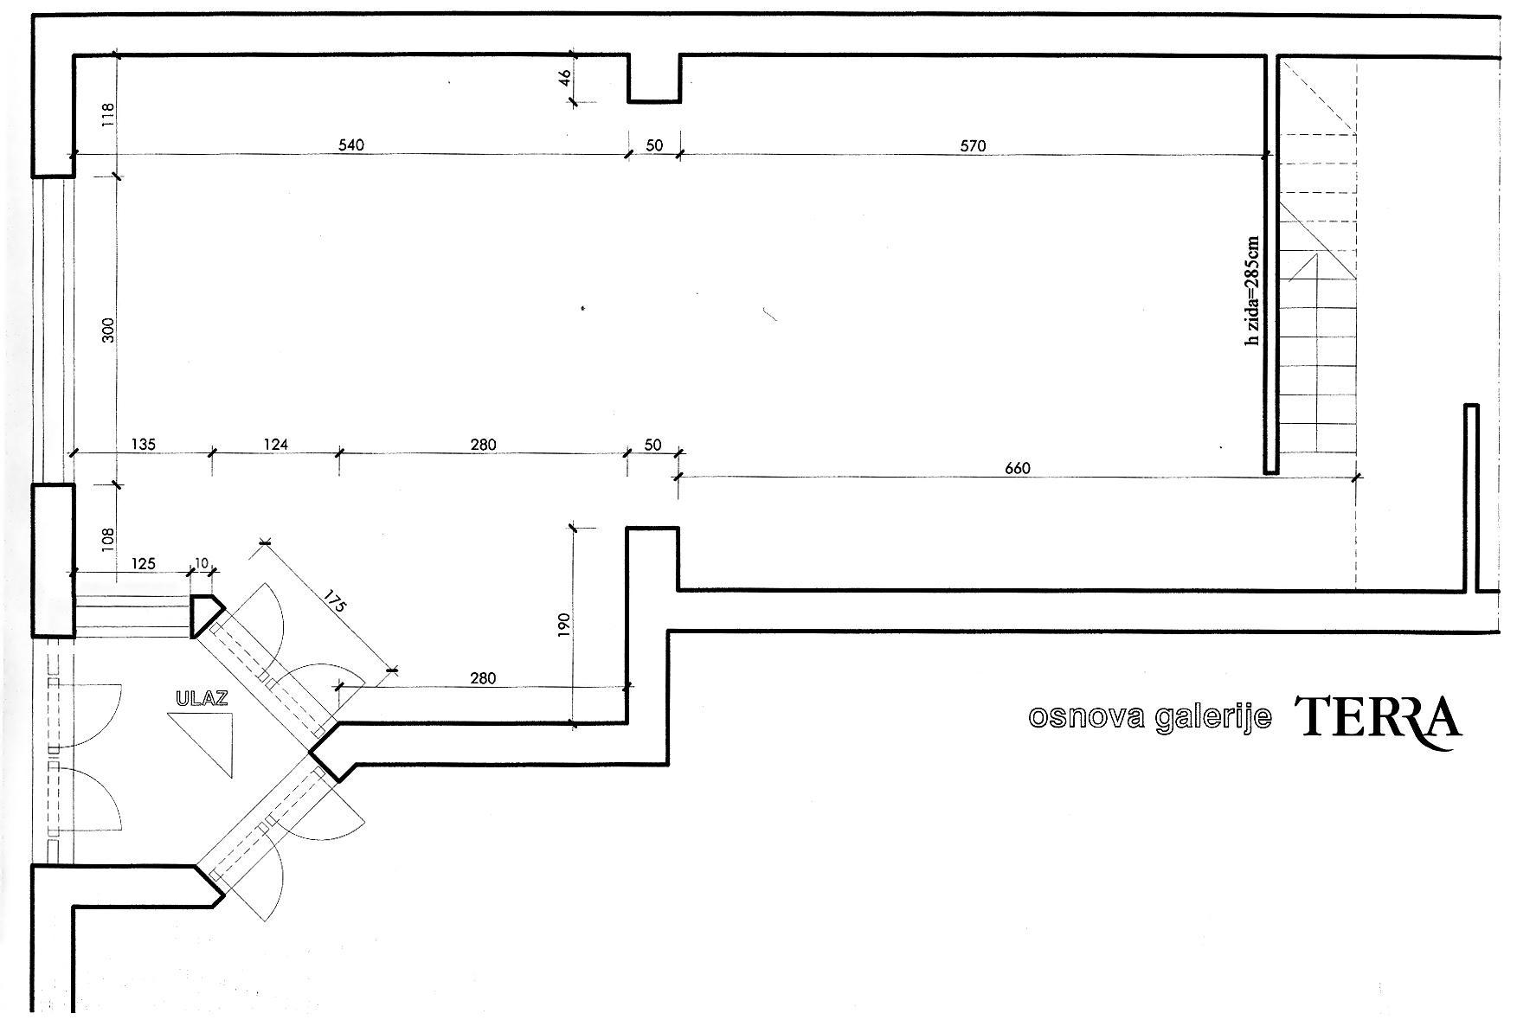

More info on: <https://terra.rs/about-gallery/>

# 

# APPENDIX 2. MUSEUM TERRA SALON - FLOOR BASE

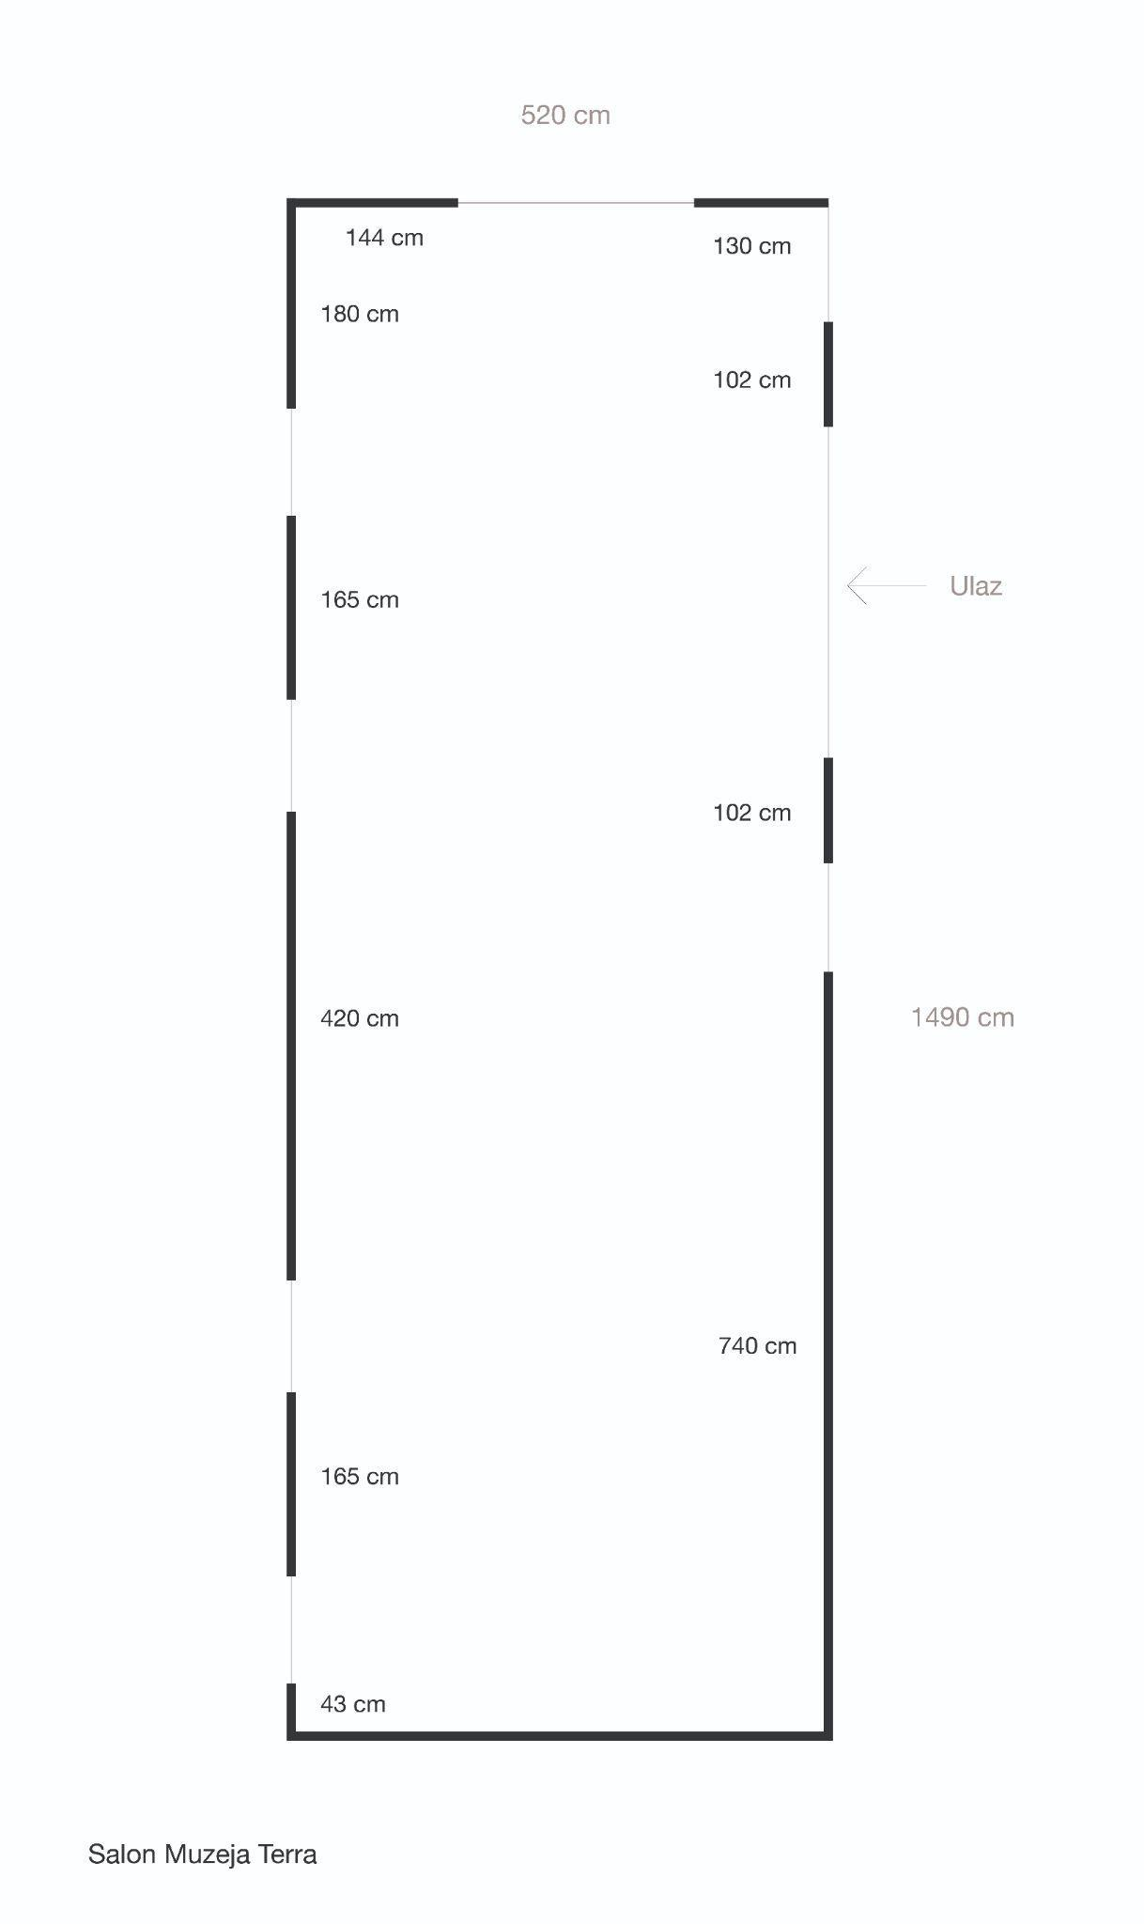

More info on: <https://terra.rs/museum-salon-archive/>

# 

# APPENDIX 3. MUSEUM TERRA SMALL SALON - FLOOR BASE

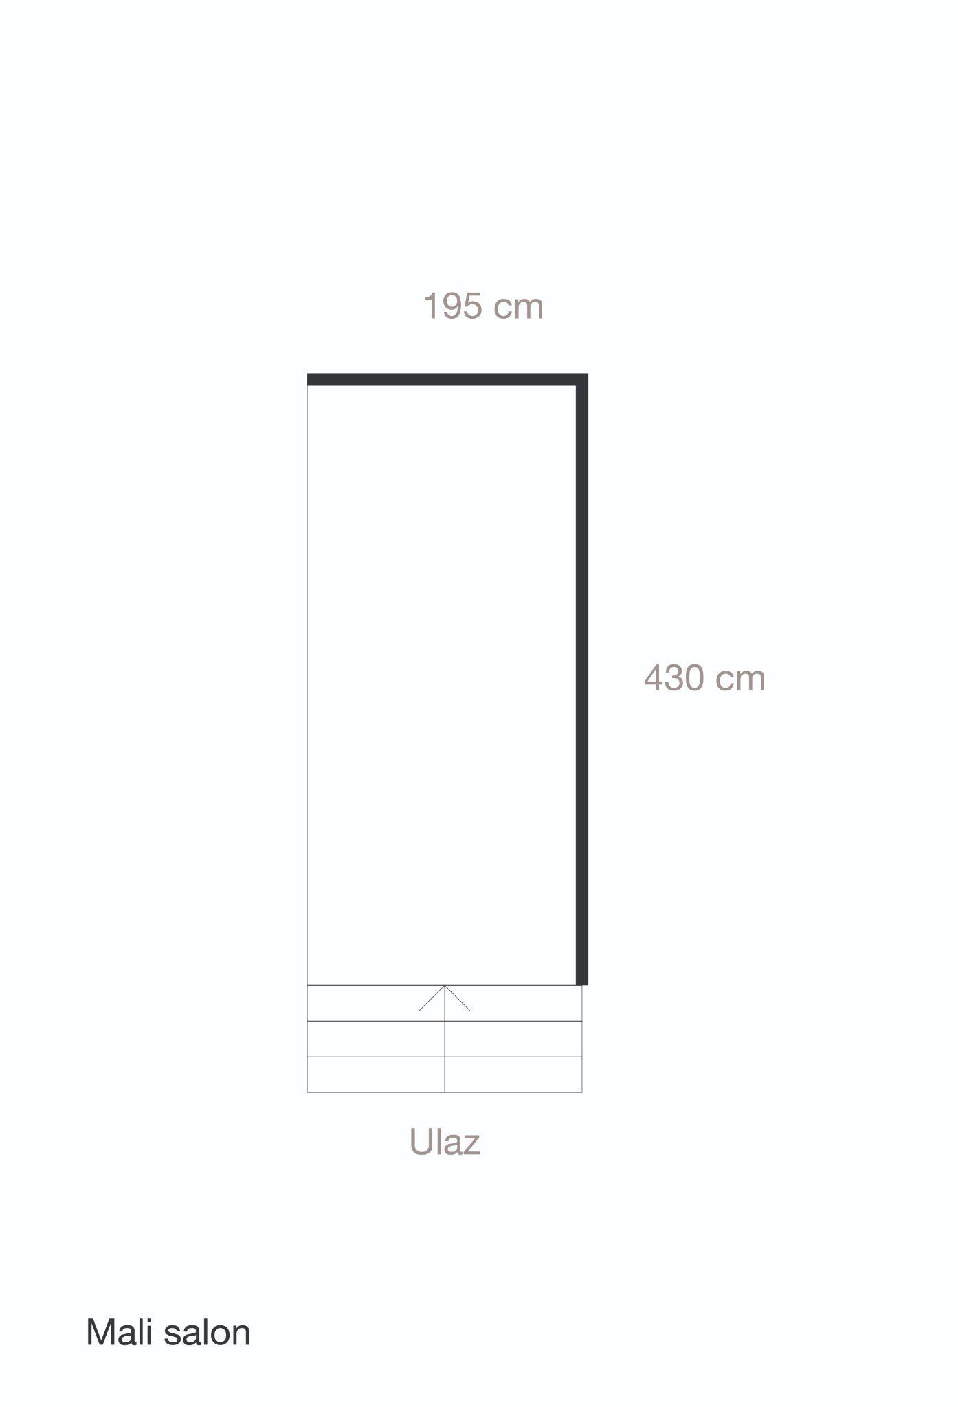

More info on: <https://terra.rs/museum-salon/uroburos/>

# APPENDIX 4. APPLICATION FORM

| **About the Applicant** | |
| --- | --- |
| Name and surname |  |
| Address |  |
| Phone No. |  |
| E-mail |  |
| Web page (if exists) |  |
| Short bio (up to 500words) |  |

| **EXHIBITION/PROJECT Description** | |
| --- | --- |
| Title |  |
| Year of creation |  |
| Technique |  |
| Short description  (up to 500 words) |  |
| **TECH SPECS** | |
| Number od suggested works |  |
| Dimensions |  |
| Number of required postaments |  |
| Additional equipment (if needed) |  |
| Other notes |  |